Output Checking Exam

Exam no. 5, January 2025

Candidate details
Name
Email address
Person to be notified of results | (Optional)

Instructions to candidates
There are two parts to the exam: technical checking of outputs (70%), and an essay question (30%). You must get 50% in the technical section, and 50% overall, to pass.
Guidance on the outputs can be found in the SACRO manual https://zenodo.org/records/10054629. This should be treated as the definitive source. You should make yourself familiar with the statbarns concept, and with the section on evaluation of risk. You should apply a default threshold of 10 units unless otherwise instructed. Output checking in this exam is principles-based. You do not need to treat outputs as exception requests unless explicitly requested to do so; however, you may you choose to treat as an exception even if not explicitly asked. If an exception is requested, you must evaluate that exception request.
Having completed this document, save it as a PDF and upload to http://www.saferesearchertraining.org/occ/submit.html. Ater initial marking you will receive a pass/fail grade only. In the event of a failure the UWE team will contact you to discuss options. After the test has been retired (usually at the end of the year), more detailed feedback will be made available.
Please complete by the date shown on page 2 using the submission site. A model answer for previous tests can be found on the submission site.

Part 1: output checking
For each of the outputs presented below:
- Provide an evaluation of the output, max 100 words, noting
  - Whether this is a ‘safe’(low review) statistic or not, and which statbarn it relates to
  - Possible and likely risks to confidentiality, such as sample size and how likely it is that membership of the sample is known
  - Whether the information you require to make a decision is clear, can be reasonably inferred, or is missing
- Decide what action you will take
- Explain the reasons for your action (following the guidelines below); max 100 words
- Outline in bullets the key points you will make to the user (if any); max 80words
Option | Please explain…
Approve | Why there are no reasonable disclosure risks
Reject | If rejecting as being disclosive, describe the chain of events that plausibly and reasonably lead to this output revealing information about an identifiable individual  If rejecting for breaking rules or rules-of-thumb, explain which specific rule is being broken (NOTE: some of the outputs below may request release under PBOSDC as exceptions to the rules. You may NOT reject these for breaking rules).  If rejecting for others reasons, explain
Ask for further information | What specific information is required to make a decision? Why could you not have reasonably inferred this information from the result?

Part 2: Essay
Please write up to 400 words on the subject specified. Marks are based on (a) ability to discuss both sides of the topic (b) use of evidence in coming to conclusions. You may draw on the practices of your own organisation but are not required to support or oppose those practices

Privacy
Opinions will be assessed for marking only and will not be relayed to other organisations. However, general (unidentified) feedback will be passed to the output checking Expert Group for the purposes of reviewing both the course and output checking guidelines.
Complete and submit to http://www.saferesearchertraining.org/occ/submit.html by [see website for submission date] to be included in the next marking round.

Q1: Survival rates for hospital stays
Dear clearance team, please find below survival rates during extended hospital stays. The data are from Glasgow Hospitals Trust Jun 2019-Jan 2020. The focus is on the ‘Christmas effect’, so I have included graphs with both absolute times and relative times for three comparator periods.
 | N. admissions  T=0 | Surviving  T+31
Jul-Aug | 1037 | 742
Oct-Nov | 1428 | 1025
Dec-Jan | 1720 | 1255

Hazard estimation
 | All observations |  |  |  | Conditional on survival first week
 | Coeff. | Std. err. | z | P>z | Coeff. | Std. err. | z | P>z
Festive period | -0.043 | 0.014 | -3.160 | 0.002 | -0.107 | 0.015 | -6.950 | 0.000
Scheduled admission | 0.174 | 0.071 | 2.460 | 0.014 | 0.210 | 0.077 | 2.740 | 0.006
Married | 0.535 | 0.109 | 4.900 | 0.000 | 0.485 | 0.121 | 4.020 | 0.000
Age | -0.111 | 0.046 | -2.430 | 0.015 | -0.113 | 0.047 | -2.380 | 0.017
c | 0.823 | 0.273 | 3.010 | 0.003 | 1.913 | 0.301 | 6.370 | 0.000
N | 4099 |  |  |  | 3588
LR chisq | 40.580 |  |  |  | 60.720
Pseudo-R2 | 0.007 |  |  |  | 0.014

Analysis
(max 100 words)
Action
Rationale
(max 200 words)
Notes for researcher
(max 80 words)

Q2: Treatment outcomes
The graphs and tables below are from the GargleBlaster follow-up study (2023-2024 clinical trial), showing treatment effects for both basic and supplementary treatment groups. I’ve removed low numbers from the table in line with guidance but I assume this is okay for the graphs as there is no information which would allow anyone to be identified, and the small tails are important for the project.
Basic descriptives
 | No measurable  effect | Major  reduction | Minor  reduction | Other cardiac  reaction | Reduction +  other cardiac | Other | Total
Group
Control | 161 | x | 86 | x | x | x | 267
Treatment A only | 222 | x | 73 | x | x | x | 326
Treatment A+B | 223 | 10 | 50 | x | x | x | 296
Sex
female | 174 | 13 | 106 | 11 | x | x | 314
male | 434 | 15 | 103 | x | 12 | x | 577

X= under 10, omitted
Alluvial flow of treatments and outcomes
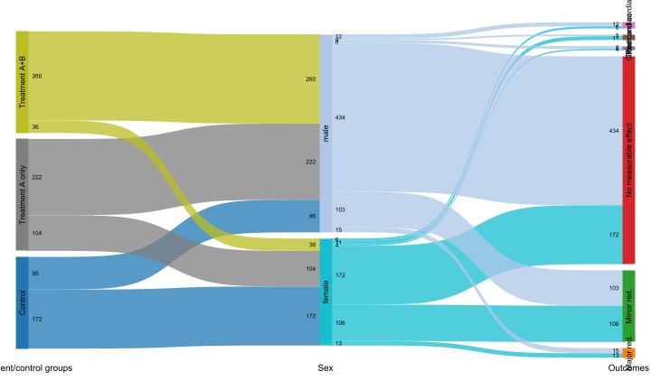
Analysis
(max 100 words)
Action
Rationale
(max 200 words)
Notes for researcher
(max 80 words)

Q3: Earnings distributions
Dear team, please release these findings from the Wages and Employment Survey 2014. This is a 0.2% random sample for the workforce. Results below are for gross weekly wage and are only for those in work on the survey date (Sept 4th). There are some low numbers but would like to keep as the similarity in low wages and difference in high wages is the key research finding I want to show.
Normalised Lorenz curves (a) all regions separately (b) all regions on same graph 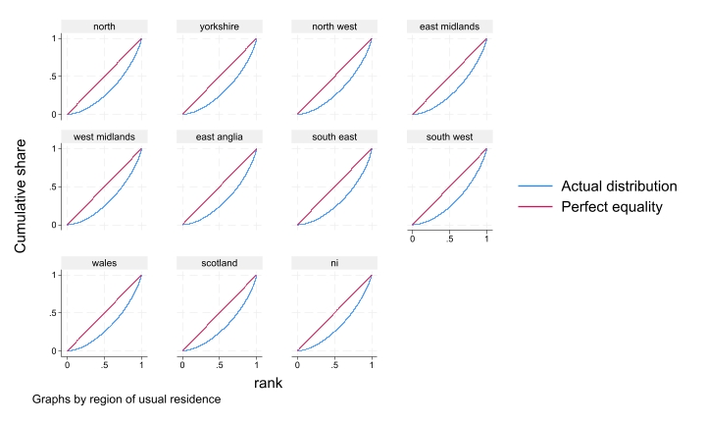
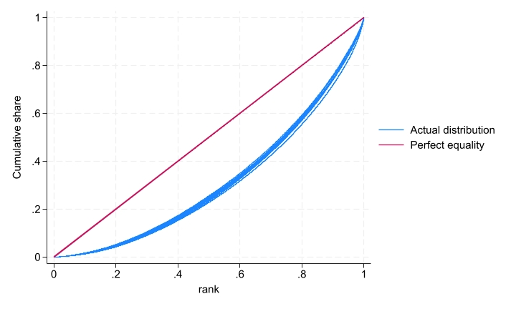
[Continued on next page]
Distribution tabulated:
 | N | Mean | Percentiles |  |  |  |  | Gini  coefficient
Region |  |  | 1% | 25% | Median | 75% | 99% | Gini  coefficient
north | 1,700 | £302 | £17 | £155 | £254 | £404 | £1,035 | 0.6283
yorkshire | 2,850 | £309 | £21 | £156 | £262 | £404 | £1,154 | 0.6272
north west | 2,721 | £323 | £22 | £162 | £277 | £423 | £1,154 | 0.6310
east midlands | 2,431 | £313 | £19 | £155 | £265 | £413 | £1,085 | 0.6233
west midlands | 2,784 | £332 | £20 | £172 | £288 | £442 | £1,177 | 0.6310
east anglia | 1,148 | £334 | £25 | £173 | £281 | £438 | £1,288 | 0.6205
south east | 9,833 | £415 | £24 | £200 | £346 | £534 | £1,731 | 0.5998
south west | 2,944 | £322 | £20 | £152 | £277 | £433 | £1,096 | 0.6175
wales | 1,408 | £303 | £18 | £163 | £260 | £405 | £981 | 0.6401
scotland | 3,029 | £332 | £25 | £166 | £279 | £442 | £1,231 | 0.6273
ni | 725 | £295 | £20 | £155 | £260 | £390 | £865 | 0.6470
All regions | 31,573 | £349 | £21 | £171 | £288 | £462 | £1,368 | 0.6190

Analysis
(max 100 words)
Action
Rationale
(max 200 words)
Notes for researcher
(max 80 words)

Q4 Fire survival rates
Dear Team, please find attached my analysis using the accidents at work database. My research explores office fires for the county of Gibbleshire on behalf of the national public health enquiry into work safety in Gibbleshire. Gibbleshire boasts the largest concentration of offices in England, with approximately 300 million square feet of built offices and 700,000 workers. The first part of the analysis explores the survival outcomes for the infamous Great Gibbington Fire of 2022 that engulfed 5 offices in the county city of Gibbington (N=154)..
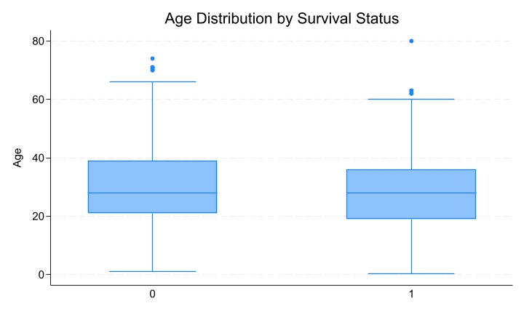

The second part of the analysis focuses on the total number of office fire incidents in Gibbington for 2022 and explores office worker survival, worker position (higher management, lower management, admin staff) and age. The public enquiry seeks to answer whether the entry level staff had greater survival than senior management, to explore this a two way ANOVA with interaction determines whether the effect of survival status (Survived) on Age depends on the worker class, and vice versa. As demonstrated the ANOVA shows that there is not a significant interaction and furthermore this linear graph depicting how the relationship between Survival Status and Age remains consistent across Worker Classes without any notable deviations.

[Continued on next page]

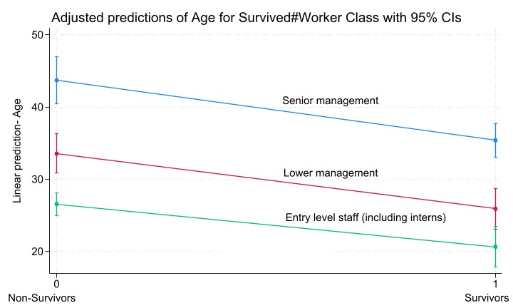
Source | Partial SS |  | df | MS | F | Prob > F
Model | 28,620.302 |  | 5 | 5,724.0605 | 33.26 | 0.0000
Survived | 7,665.5544 |  | 1 | 7,665.5544 | 44.55 | 0.0000
Workerclass | 25,840.712 |  | 2 | 12,920.356 | 75.08 | 0.0000
Survived#Workerclass | 167.5447 |  | 2 | 83.772352 | 0.49 | 0.6148
Residual | 121,836.33 |  | 708 | 172.08522
Total | 150,456.64 |  | 713 | 211.01912
- Number of Observations: 714
- R-squared: 0.1902
- Adjusted R-squared: 0.1845
- Root MSE: 13.1181

Analysis
(max 100 words)
Action
Rationale
(max 200 words)
Notes for researcher
(max 80 words)

Part 2: Essay
What are the advantages and disadvantages of the Statbarns approach to SDC?

End of test

