Output Checking Test

Scores and model answers

The test used Autumn 2019 – Spring 2020 is given below with model answers. Candidate scores in this period were
 |  | Mean | SD | Min | Max
Short answers
 | Q1 | 70.0 | 10.3 | 52 | 90
 | Q2 | 47.1 | 26.2 | 10 | 100
 | Q3 | 78.5 | 24.6 | 40 | 100
 | Q4 | 59.9 | 12.5 | 35 | 85
Short answers overall |  | 63.9 | 9.3 | 52 | 84
Essay |  | 66.3 | 19.0 | 35 | 90
Total |  | 64.6 | 9.6 | 51 | 85

Output Checking Exam

Instructions to candidates
There are two parts to the exam: checking of outputs (70%), and an essay question (30%). Please complete the boxes in this document. On completion, save this document without personal identifiers (ideally PDF) and upload it to http://www.saferesearchertraining.org/occ/submit.html. You will automatically be given a reference number which will be used to identify responses during marking. You will receive a commentary on your response and ONS will be informed of passes.
Please complete by the date shown on page 2.

Part 1: output checking
For each of the outputs presented below:
- Provide an evaluation of the output in less than 100 words, noting
  - Whether this is a ‘safe’(low review) statistic or not
  - Possible and likely risks to confidentiality
  - Whether the information you require to make a decision is clear, can be reasonably inferred, or is missing
- Decide what action you will take
- Explain the reasons for your action (following the guidelines below); max 200 words
- Outline in bullets the key points you will make to the user (if any); max 80words
Option | Please explain…
Approve | Why there are no reasonable disclosure risks
Reject | If rejecting as being disclosive, describe the chain of events that plausibly and reasonably lead to this output revealing information about an identifiable individual  If rejecting for breaking rules or rules-of-thumb, explain which specific rule is being broken (NOTE: some of the outputs below may request release under PBOSDC as exceptions to the rules. You may NOT reject these for breaking rules).  If rejecting for others reasons, explain
Ask for further information | What specific information is required to make a decision? Why could you not have reasonably inferred this information from the result?

Part 2: Essay
Please write up to 400 words on the subject specified. Marks are based on (a) ability to discuss both sides of the topic (b) use of evidence in coming to conclusions. You may draw on the practices of your own organisation but are not required to support or oppose those practices

Privacy
Opinions will be assessed for marking only and will not be relayed to other organisations. However, we may general (unidentified) feedback will be passed to the output checking Expert Group for the purposes of reviewing both the course and output checking guidelines.

Output Checking Exam August 2019

Complete and submit to http://www.saferesearchertraining.org/occ/submit.html by Weds 28th August 2019

Part I output assessment (70%)
The first two outputs are taken from a panel of 150 charities. Up to 6 years financial data is recorded 2010-2015. Roughly half the charities ceased trading in 2015.
The second two outputs are taken from an adulterated version of the 2002 Labour Force Survey teaching dataset, with approximately 32,000 respondents.

Q1 Output
Hello
Please clear these outputs (regression and stats on dependency rates) from the charity data.
Thanks
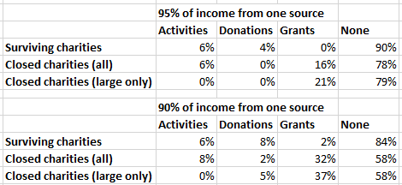
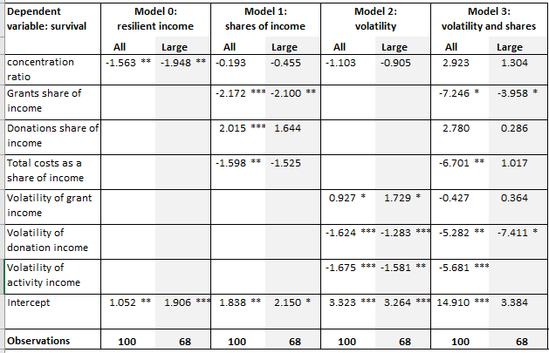

Q1 response:
Analysis  (max 100 words) | Top tables:  - Important point is to understand what is being shown. The first box shows that, for surviving charities, 6% have over 95% of their income just from activities, 4% have over 95 of income from donations, and none have over 95% of income from grants  - Not clear whether these stats are calculated by charity (ie 150 obs) or by observation (600-odd in total)  - Immediate problem: counts missing; can be reasonably calculated: the dataset description tells us that roughly half of all the charities close, and it’s unlikely that the researcher would have split the dataset into small and big so that almost none or almost all of the big charities survived; so around 75 charities in the survivor/closed rows and 30-40 charities in the large, closed row; if these are %s per charity, then all fthe cells below 10% have counts < 10; if however these are %s per observation (5-6 per charity) then only the smallest %s in each row have counts below 0  - Are the zeros structural? No- clearly possible to have zero in any box  - Are the zeros important? No. A zero means that there are no charities in a group which have more than 90 or 95% of their funding from the stated source. It doesn’t say that they have no funding from that source, or that most of their funding is or isn’t from that source. There is no meaningful disclosure  - Unsafe in theory, safe in this particular instance, but probably doesn’t meet threshold rule  Model  - not fully saturated  - many degrees of freedom  - safe
Action | Could be rejected as no counts given  Better: (1) approve but remind researcher to add counts, or (2) reject because no counts and probably there are counts<10
Rationale  (max 200 words) | Rejection for no counts is harsh, as the table is non-disclosive and you can make a reasonable estimate of counts anyway  Rejection because no counts and it is likely that counts < 10 is valid, because that’s why we have rules, and you shouldn’t have to make estimates of counts  - In other words, be very clear about why you are rejecting – it’s for process reasons, not because it’s disclosive  Approve if this is a genuine oversight or has some history to it, but a gentle reminder to researcher will help (you want to rain peple to do it properly, not put their backs up); effectively, you are asking yourself for the exception that the researcher didn’t
Notes for researcher  (max 80 words) | If rejecting: please give counts, and if those are less then 10 make clear (a) why the figure is nondislcosive and (b) why we should make an exception  If approving: we’ve released this time, but do it better next time as we’ll not be so accommodating  If you struggled to understand the data being presented, make that clear to the researcher too
What candidates mostly got wrong in this question | Many confused “not meeting rules” with “presents a disclosure risk”. The latter isn’t valid in this case. The former is ok as a reason for rejection, but candidates weren’t clear.  If you reject for the wrong reason, you run the risk of starting a debate with the researcher which is time-consuming, unproductive and may worsen relations

Q2 Output
Dear SRS team, I’m aware that min/max aren’t normally allowed but this is important to show the range of variation in the charities’ financial situations). Note that volatility is defined as st.dev. of variable over 2010-2015, calculated for each charity.
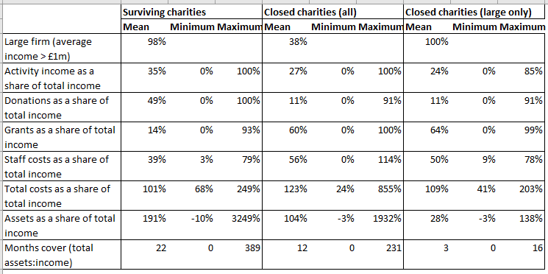
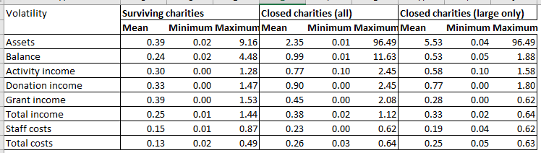

Q2 response:
Analysis  (max 100 words) | First max/min table  - Initial analysis: max/min often relate to single cases (esp. max) and so fail the threshold rule; income shares are bounded at 0% and 100%; asset shares have some extreme outliers; no counts given  - Exception requested=> we need to evaluate the figures: what does a max represent, for example? Consider the most extreme, the 3249% on assets; this implies that one (almost certainly just the one) charity has, at some point over the six years, had a share of assets much higher than the mean; however, no idea whether this is a big or small firm – could be because assets are very large, or income is very small, or both; in theory, if you knew which charities were in the dataset then you could search through corporate records for all the charities and try to find the one with this extreme values – but that would only confirm what you know, even in the unlikely event that you had all of this supporting information  - Unsafe in theory; doesn’t meet threshold; but safe in this particular instance  Volatility table  - Standard deviation is safe statistic => no disclosure risk assuming sufficient degrees of freedom and not all values the same  - Comparison of mean and min/or max shows not all same values across dataset and at least some valid st devs, so even if individual charities have set at true zero (not just rounded to 0.00) we can’t identify them.  - safe
Action | Release
Rationale  (max 200 words) | Safe in this instance; theoretically max/min disallowed but exception requested
Notes for researcher  (max 80 words) | In future, please make clear whether the first table refer to observations or charities
What candidates mostly got wrong in this question | Major problem: ignoring the request for an exception and rejecting on the basis of max/min presence  Minor problem: not bothering to work through whether any disclore risk in reality  This was the lowest-scoring question, because many candidates ignored the request for an exception

Q3 Output
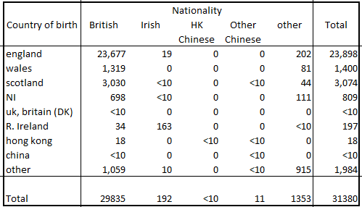
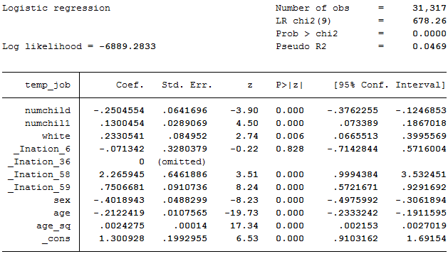

Q3 response:
Analysis  (max 100 words) | Table:  - Zeroes – are the structural? No; Are they disclosive? Not really- little surprise that nationality is rarely different from country of birth  - Numbers less than ten set to “<10” – do the totals reflect actual number displayed, or do they reflect the hidden values (and so allow elements to be reconstructed)? Answer: former, so okay  - Pearson’s chisquare- safe  - Does the difference in observations between the regression and table raise any issues? No – no idea why some observations were excluded for the regression  - Unsafe in theory, safe in this instance and meets rules  Regression  - Many degrees of freedom  - Not saturated regression  - safe
Action | Release
Rationale  (max 200 words) | One output safe in practice, one safe in theory and practice
Notes for researcher, if any  (max 80 words) | N/A
What candidates mostly got wrong in this question | Candidates asked for ‘more information’ without any compelling reason, rather than making a decision  Some candidates claimed that the table showed ‘dominance’ – this is not possible with a frequency table (if unsure why not, lok up the definition of ‘dominance’ in the SDC literature)  A few made comments about the statistical validity of the table – this is not a reason for rejection, and some comments to researchers would have been quite irritating  This was the best-answered question, with several candidates coring 100%

Q4 Output
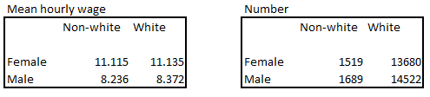
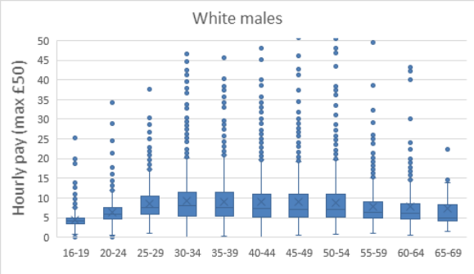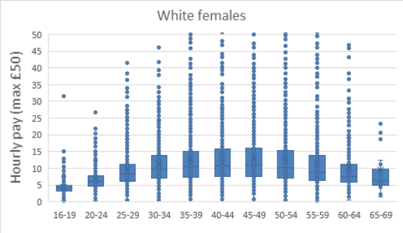
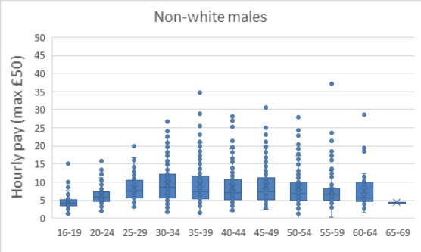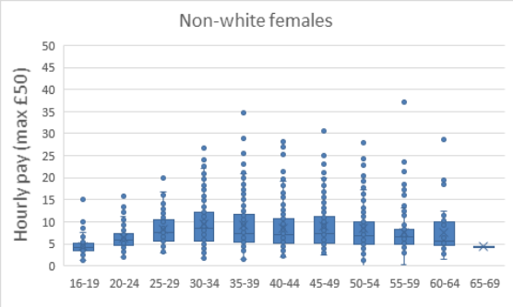
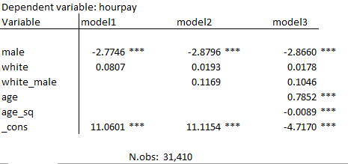

Q4 response:
Analysis  (max 100 words) | Tables  - Large numbers  - Magnitudes in first table, so potential for dominance – unlikely with this number of observations  - safe in this instance  Box plots  - Single values – potentially breaking rule?  - Maximum values? In theory no, because the plot is capped at £50/hour – but this is so high as to be irrelevant for many categories (esp. non-white), which come nowhere near it; so for some groups can be confident that the max value depicted is an actual maximum  - Is this maximum disclosive? Data is almost 20 years old so probably impossible to identify individuals unless the self-identify, but we don’t have a statute of limitations on this data  - However, max indicates that eg at least 18-19 year-old is earning about £30k pa – about 15% higher than the median wage today, let alone twenty years ago and for a young employee), so as a max this is pretty uninformative; I would have more concern that there is some error in the data points  - Graphs 3 and 4 are duplicates  - Unsafe in theory, probably safe in practice (suggest more problems with the data)  Regressions  - Sufficient degrees of freedom  - Model two has two categorical variables fully interacted (male AND white AND maleXwhite) => this ‘regression’ is just displaying means for a 2x2 table of male vs white  - However, the table would meet threshold requires (on the reasonable assumption that at least 10 people out of 31,000 would be male and white)  - An unsafe statistic, but safe in this case
Action | Several valid options
Rationale  (max 200 words) | Approve tables as safe in this instance  Reject box plots as they show individual values with no exception requested, or approve as no meaningful disclosure risk  Approve regression as actually being a table but safe in this instance, or reject as being an unsafe statistic masquerading as a safe one
Notes for researcher, if any  (max 80 words) | As several candidates suggested, limiting the box plots to 90th or 95th percentile address the theoretical issues  Researcher should be informed about the table hidden in the regression
What candidates mostly got wrong in this question | There was substantial confusion about whether the box plots showed individual values, and difficulty distinguishing between practical and theoretical risk  Only a third of candidates spotted the hidden table

Part II Essay (30%)
Q5: Outline the case for and against defining scatter plots as ‘safe statistics’. Propose guidelines for output checkers to decide if a particular output is safe for release.

Q5 response:

Case for and against scatter plots as ‘safe statistics’ | Explain the issues:  - Explain what a safe statistic is  - Show why a scatter plot isn’t ‘safe’: it shows individual points, any one of which may be disclosive; so you need to understand what is in the data before you can pass a particular plot; hence not ‘safe’  - Show why a scatter plot is generally safe in practice: multiple points on the same identification axis; easy to ensure that there are no outliers; difficult to ascribe particular values to points in a picture  - Consider the use value: scatter plots are a very handy way of describing data (especially as you wouldn’t allow a table with this data to be released)  Conclusion:  - In practice, a useful statistical output which is relatively easy to make ‘safe’ in a particular context  - However, defining it as a ‘safe statistic’ implies there is no need to check the data being displayed; there is clearly a lot of scope for disclosive outputs to be displayed  - Therefore the classification should be ‘unsafe’ (ie theoretically risky which needs to be evaluated on a case-by-case basis)
Guidelines | Three questions to consider  - Are here outliers on the category (X-) axis which are likely to identify individual data points?  - Do the implied maximum values present class disclosure issues?  - Could maximum values be in some way linked to an individual based on the information in the category axis? A plausible route to disclosure should be demonstrated, allowing for multiple observations on the category axis (or fuzziness on the X-axis if the x-axis is a continuous variable); it’s not enough to say that ‘there could be a problem’ as this is always true and so always meaningless  If the answer to all three is ‘no’ then the scatter plot should be safe for release in this particular instance  An alternative: if the scatter plot has been limited in some meaningful way, then only outliers on the x-axis need to be checked. A meaningful limit could be  - Limiting y-axis values to something which is relevant eg only showing the distribution of wages for young workers up to £10/hour is a meaningful limit; showing wages for young workers up to £100/hour is unlikely to be meaningful  - Limit plot value to the pth percentile, as long as (1-p)*n>2, where n is the number of observations in the smallest category; this is to ensure that at least 3 observations for each category are not shown on the scatter plot; for example, for 100 observations in a category, then limiting data to the 95th percentile is acceptable, but if there are only 30 observations in the smallest category, then the data should be limited to the 90th percentile.  Note that a similar rule can be applied to box-and-whisker plots
What candidates mostly got wrong in this question | Candidates who did poorly failed to distinguish between ‘safe statistics’ and ‘unsafe in general but safe in this instance’; the best candidates drew a clear distinction between “these are usually safe/easy to make safe” and “because it is easy to create scenarios where the scatter plot is disclosive, we cannot provide blanket clearance for it”  Several candidates also tackled the second part poorly, offering guidelines which were unclear, ineffective, unworkable, or sometimes just missing.

